Software Required 1

Steps to Install Terraform: 1

Installation of Azure CLI 3

Installation of V S Code 3

Creating Virtual Machine. 4

Multiple Virtual Machine Creation at a time. 10

Updating & Modification Tags on already created Resource 15

Updating 15

Modification 15

Enabling Availability Set 15

Creating Snapshot for OS Disk 15

# Software Required

1. **Terraform**
2. **Azure CLI**
3. **V.S Code**

## Steps to Install Terraform:

1. **Download the terraform from below link**

[Install | Terraform | HashiCorp Developer](https://developer.hashicorp.com/terraform/install)

1. **After downloading the terraform follow the below steps:**

* Download the terraform ZIP file from Terraform site.
* Extract the .exe from the ZIP file to a folder eg C:\Apps\Terraform copy this path location like C:\Apps\terraform\
* Add the folder location to your PATH variable, eg: Control Panel -> System -> System settings -> Environment Variables
* In System Variables, select Path > edit > new > Enter the location of the Terraform .exe, eg C:\Apps\Terraform then click OK

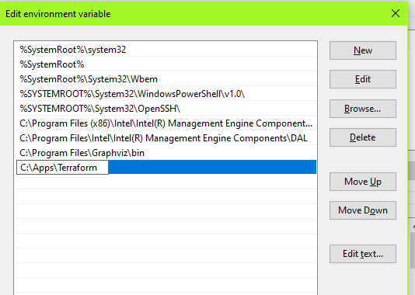

After completion of all above steps, we can verify the installation

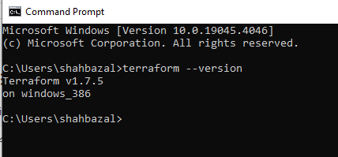

## Installation of Azure CLI

1. **Download the Azure CLI from below link**

[Install the Azure CLI for Windows | Microsoft Learn](https://learn.microsoft.com/en-us/cli/azure/install-azure-cli-windows?tabs=azure-cli)

1. **After Installation of Azure CLI, verify using CMD:**

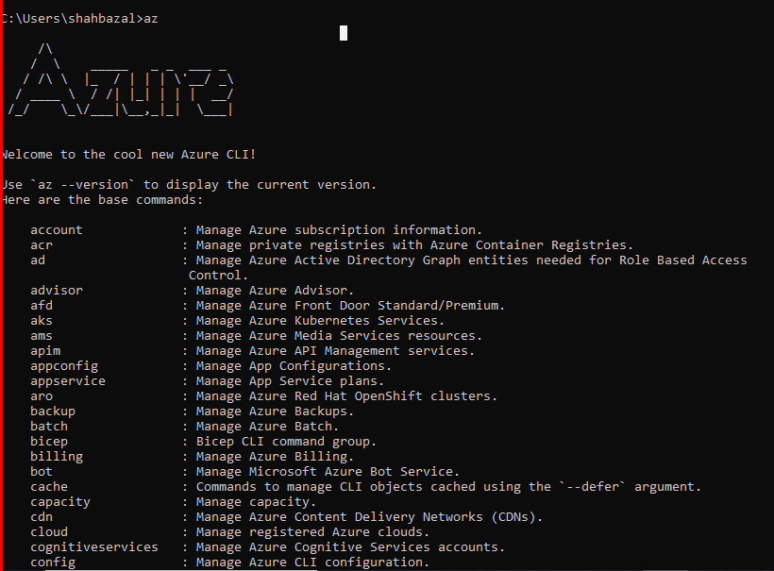

## Installation of V S Code

1. **Download the V S Code from below link**

[Download Visual Studio Code - Mac, Linux, Windows](https://code.visualstudio.com/download)

Building Infrastructure using Terraform

# Creating Virtual Machine.

**Steps:**

1. Create a folder.
2. Under folder create two files
   1. main.tf
   2. Provider.tf

In **“main.tf”** we can keep resource code “Ex. VM creation”

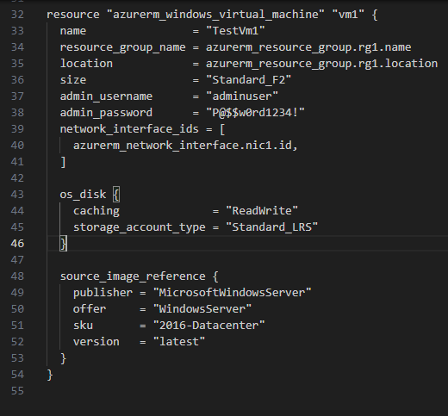

In **“provider.tf”** we can keep code of Azure Provider

To run the script, open the new terminal and follow the below commands

**1**. **az login** : To connecting to the Azure portal.

**2. terraform init**

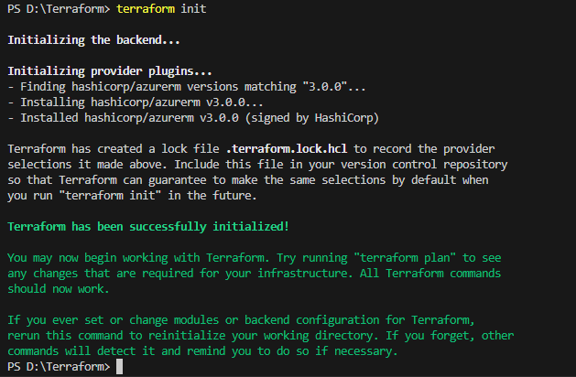

**3. terraform validate**

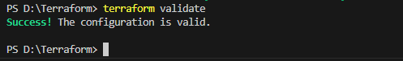

**4. terraform plan**

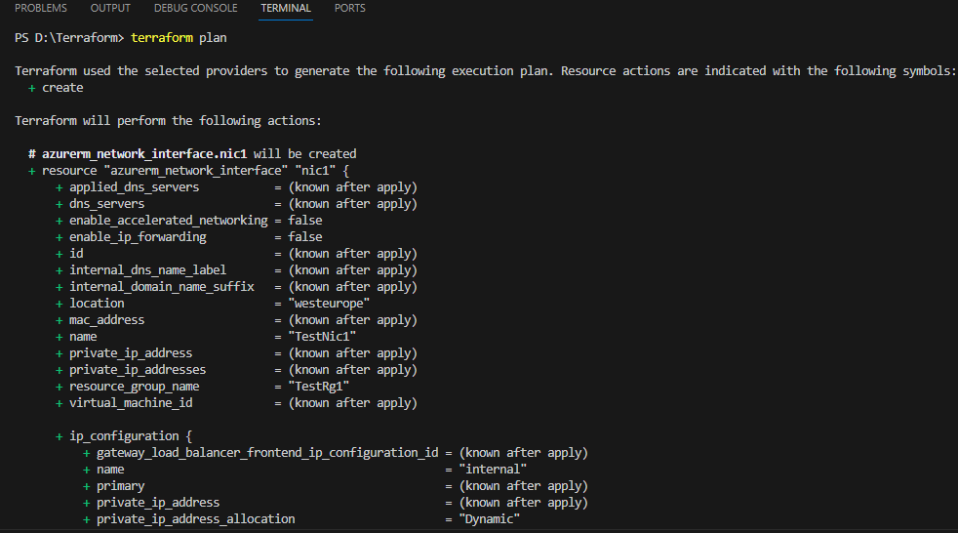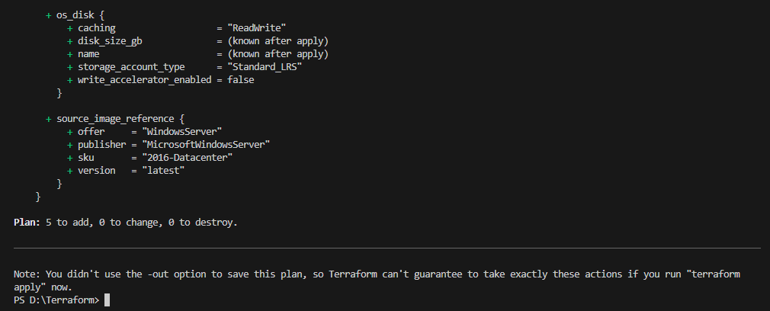

**5. terraform apply**

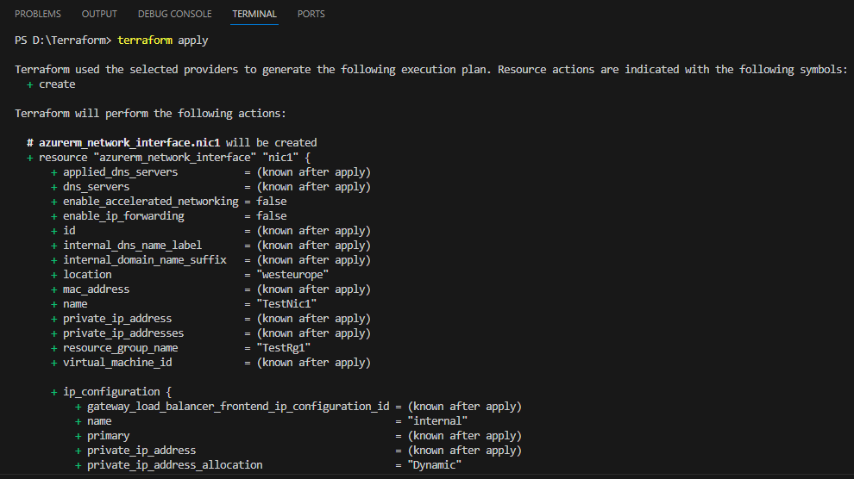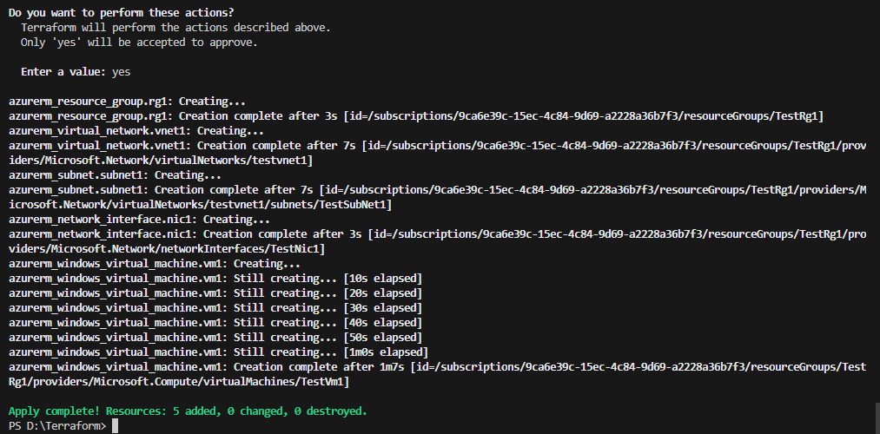

Apply is completed, 5 resource added:

1. Resource group
2. Virtual network
3. Subnet
4. Network Interface
5. Virtual machine

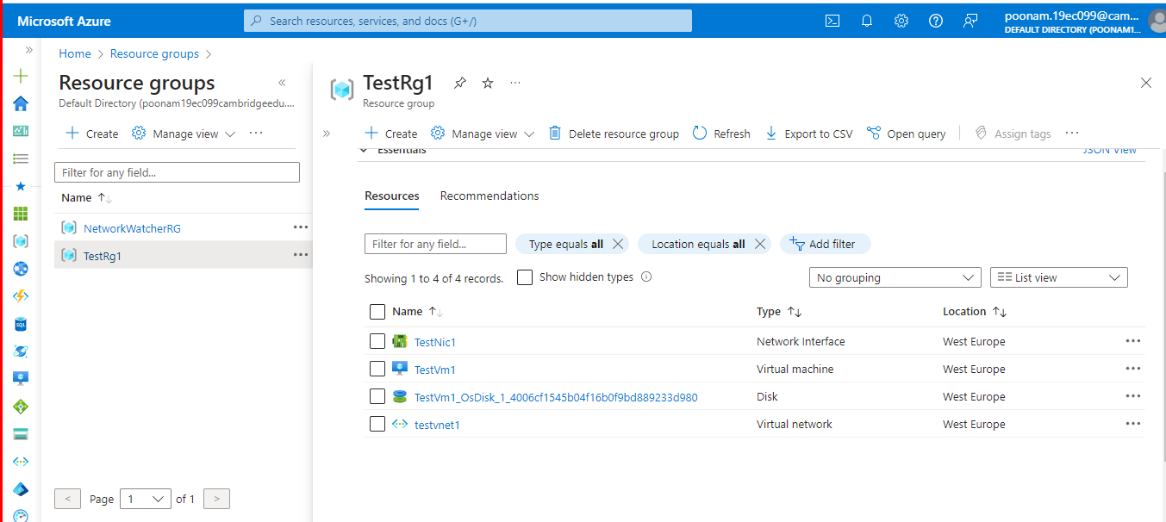

VM provisioning completed using Terraform.

# Multiple Virtual Machine Creation at a time.

**Steps:**

1. Create a folder.
2. Under folder create two files
   1. main.tf
   2. Provider.tf

In **“main.tf”** we can keep resource code “Ex. VM creation”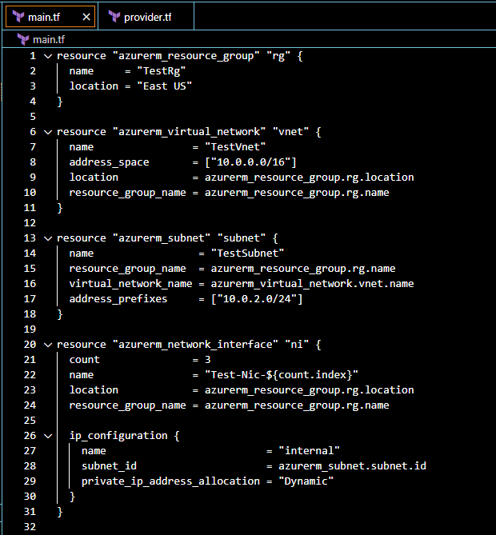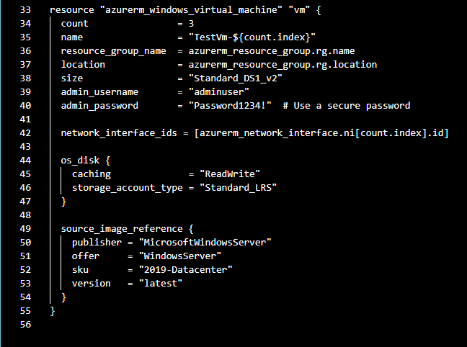  
In **“provider.tf”** we can keep code of Azure Provider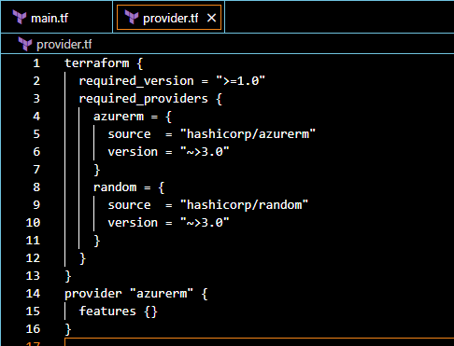

To run the script, open the new terminal and follow the below commands

**1**. **az login** : To connecting to the Azure portal.

**2. terraform init**

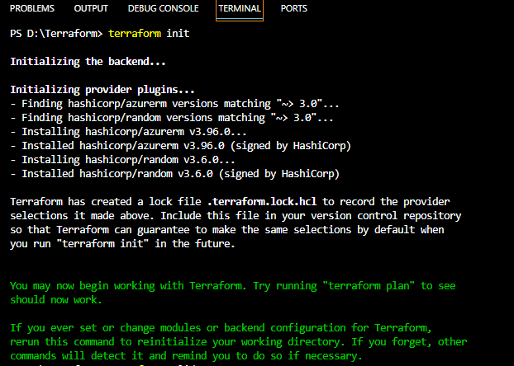  
**3. terraform validate**



**4. terraform plan**

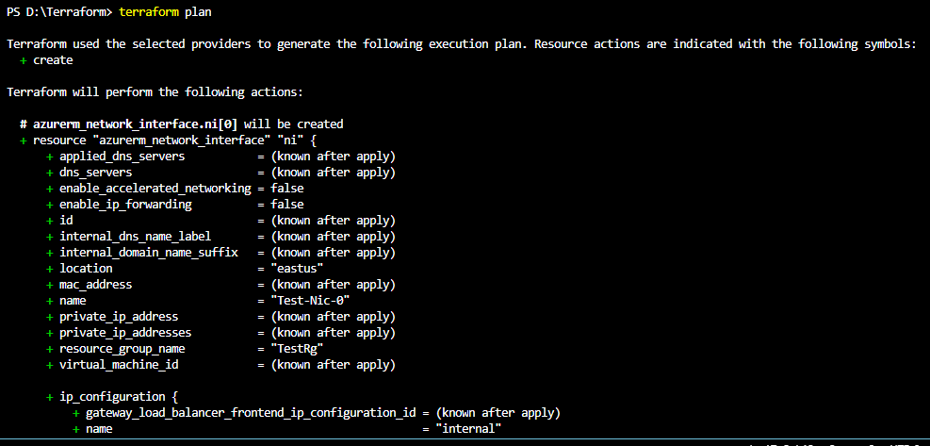  
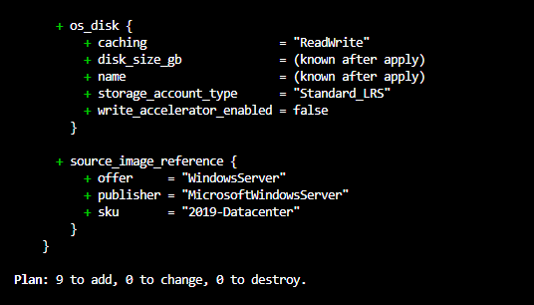

**5. terraform apply**

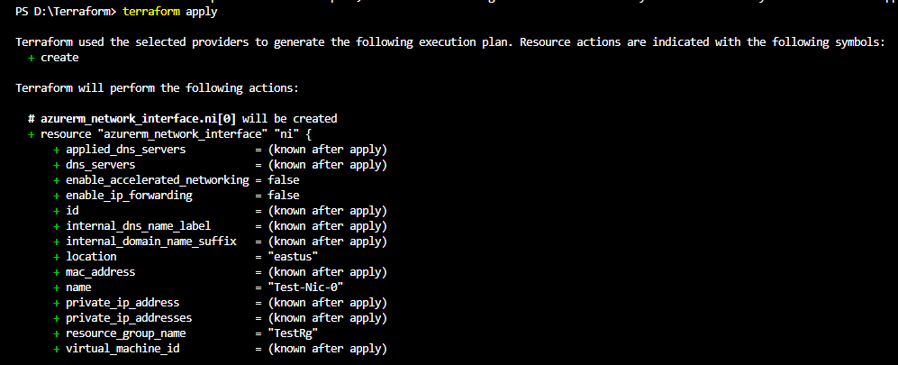  
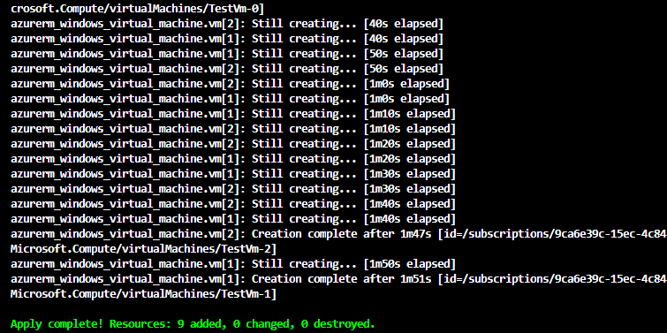  
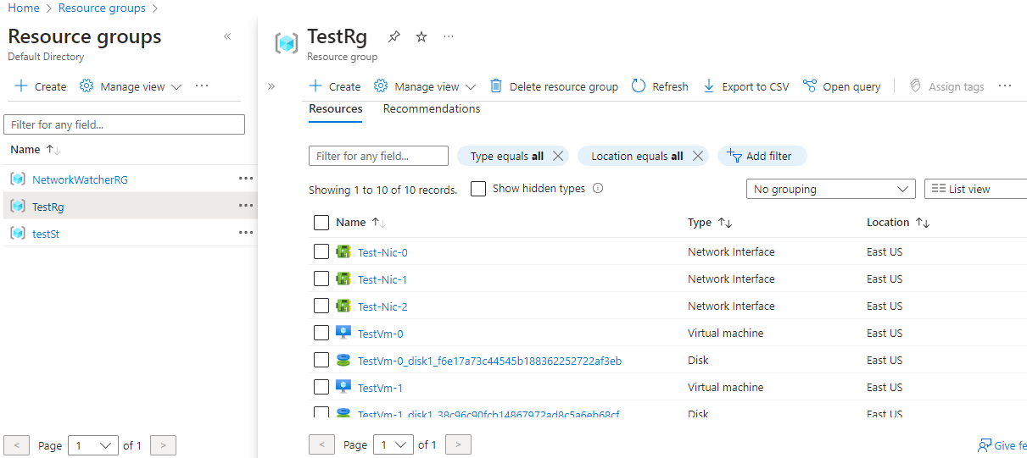  
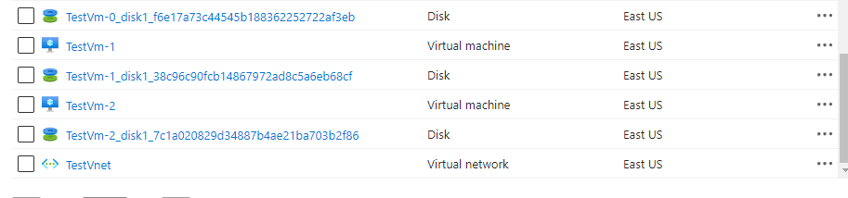

Multiple Virtual Machine Creation at a time completed using Terraform.

# Updating & Modification Tags on already created Resource

## Updating

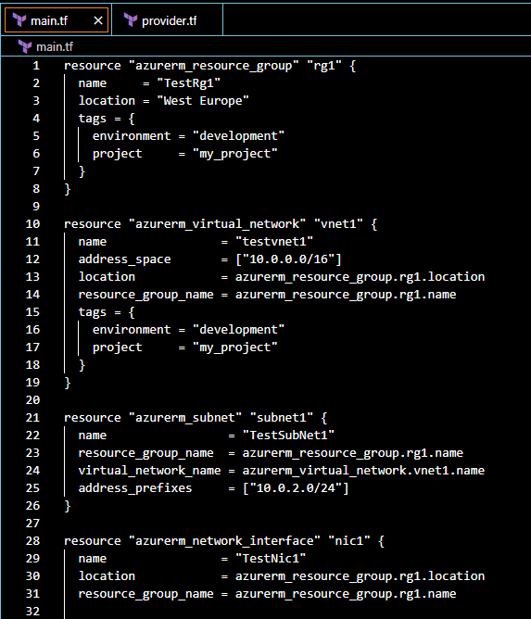

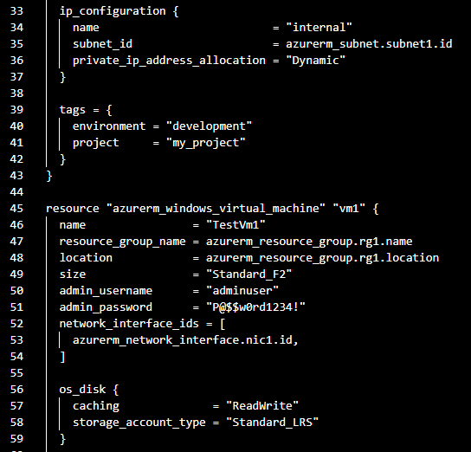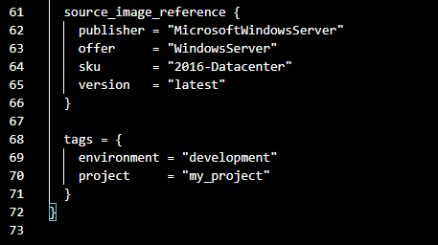

To run the script, open the new terminal and follow the below commands:

1. terraform init
2. terraform validate
3. terraform plan
4. terraform apply

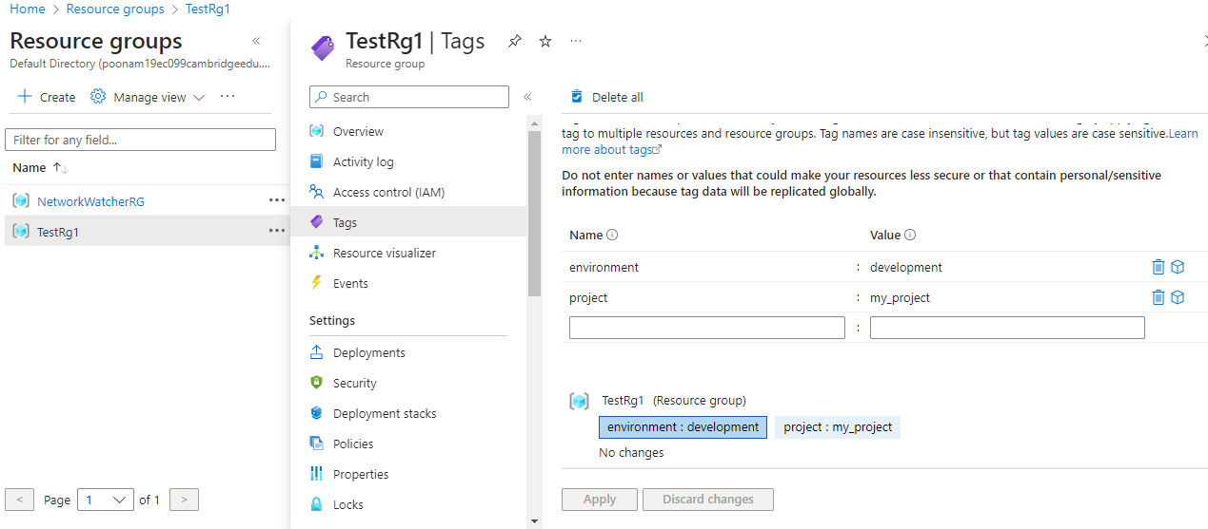

## Modification

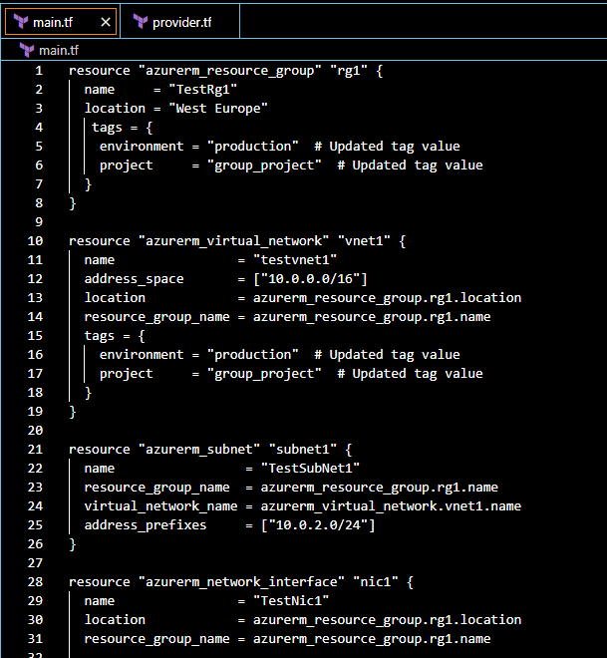

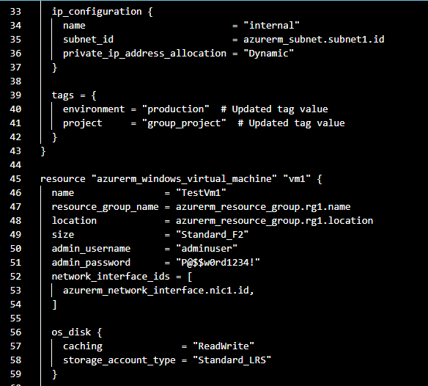

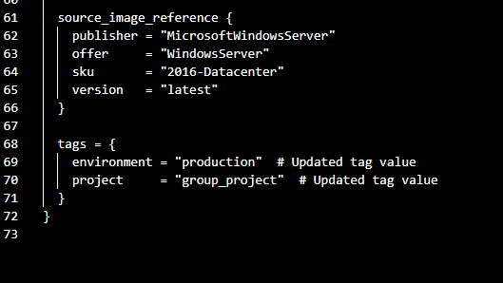

For the modification of tags, you can directly run terraform apply if you are continuously working on the same main.tf

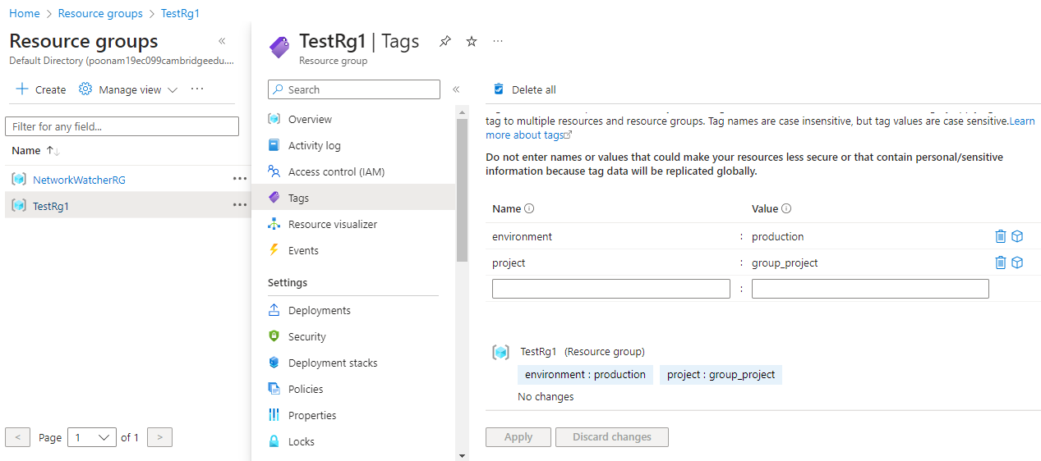

# Enabling Availability Set

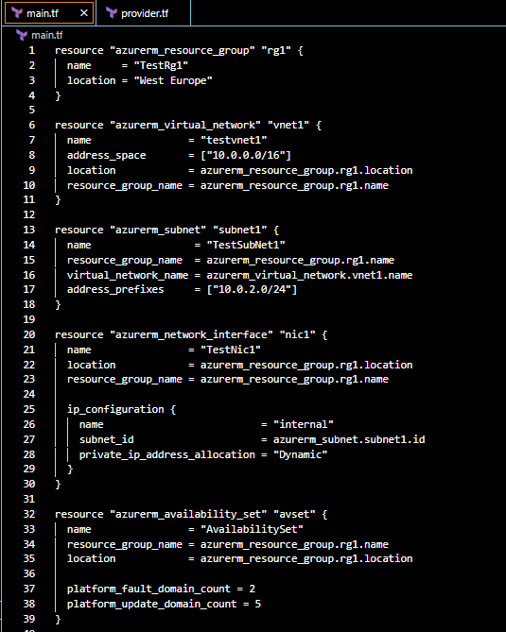

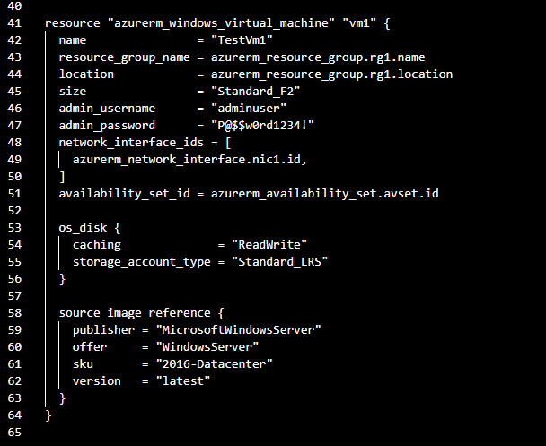

To run the script, open the new terminal and follow the below commands

1. terraform init
2. terraform validate
3. terraform plan
4. terraform apply

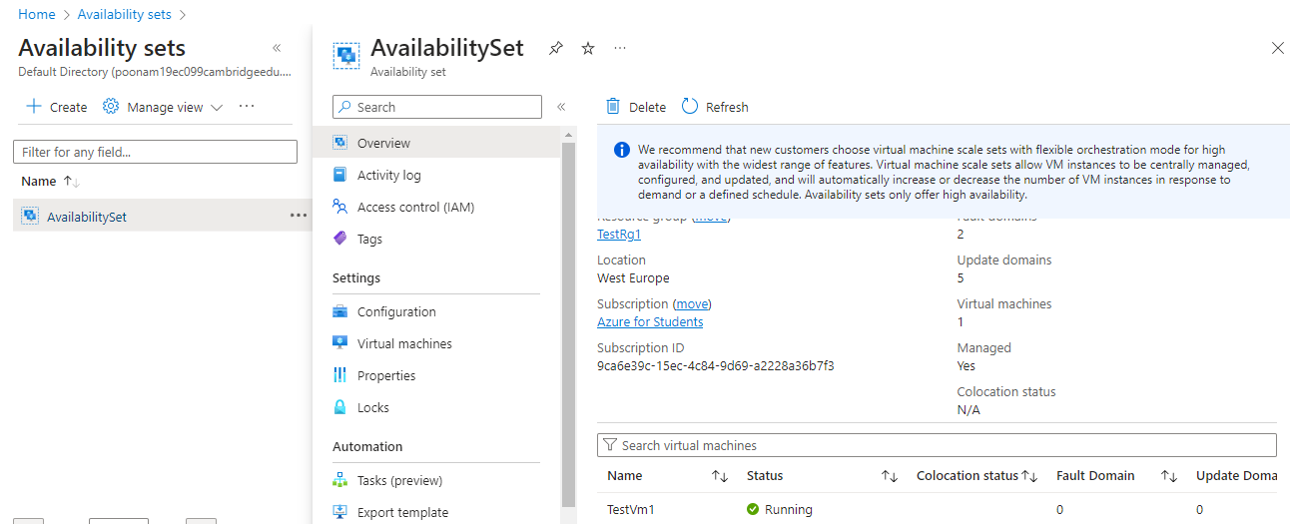

# Creating Snapshot for OS Disk

After creating the Virtual Machine, use the following line of code of Terraform

to create a snapshot for the disk.